**Bug description**

Bug 2: Player cannot reach betting limit when the limit is set to 0 but the game ends with player still with 5 (dollars) remaining. Below are the screenshots of the source code error and the actual output of the program test. As Figure 1 shown, the method is set to (balance - amount > limit) so the bug occurs when the balance is equal to the bet limit.

**Bug resolution**

1. Use greater than or equal to operator instead of greater operator in balanceExceedsLimitBy method.

Figure 1: Modified source code

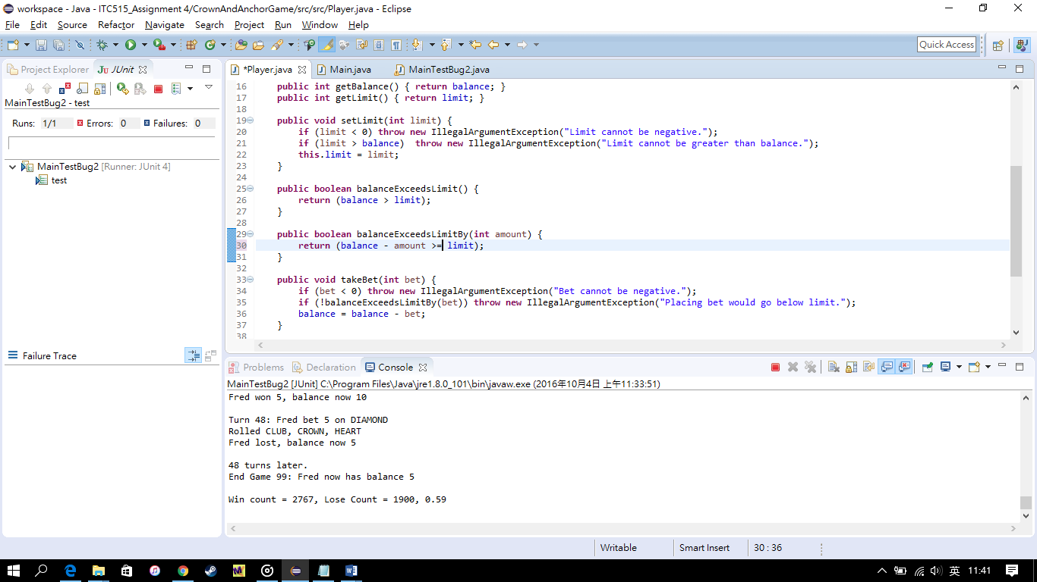

1. Test result.

Figure 2: Actual output of the program test (MainTestBug2.java)

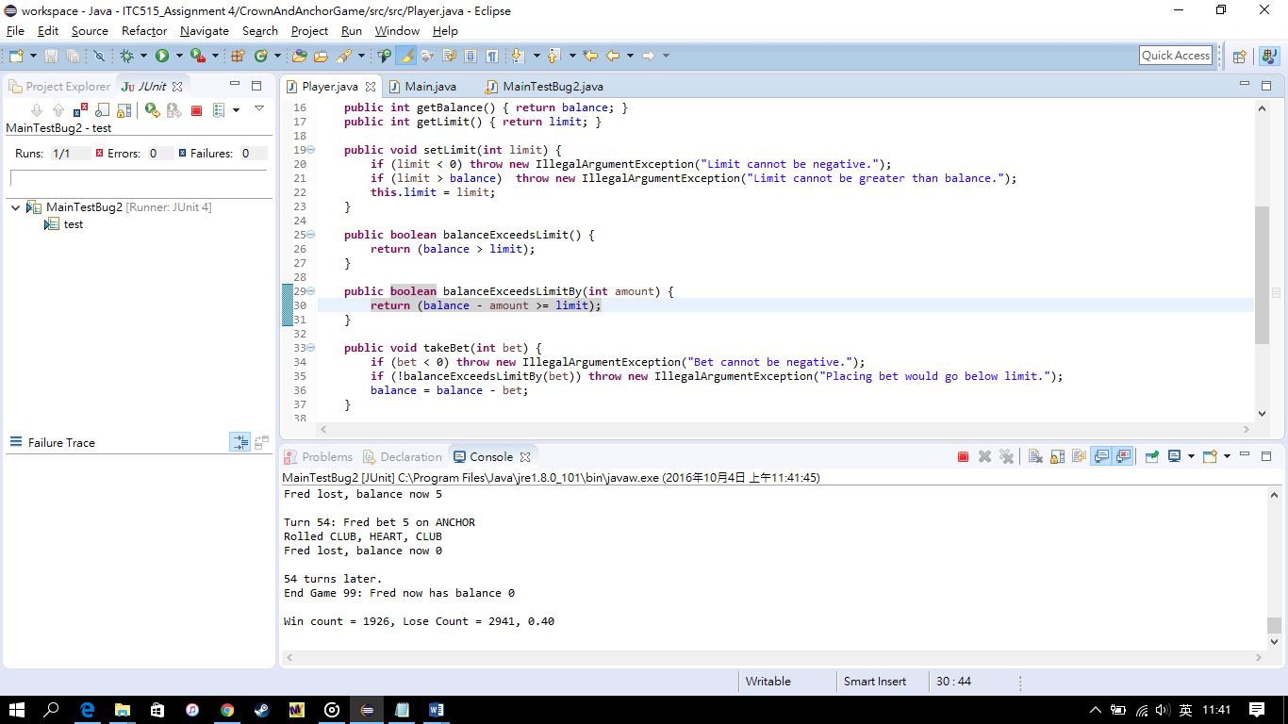

As Figure 2 shown, the player ends with the game with zero balance so the bug is fixed.